Microcontroller Training Lesson 02 – Getting Started
By Bryan A. CrazyUncleBurton Thompson
Last Updated 3/8/2026

Overview
This lesson will show you how to compile and upload a basic “Hello World” program to a microcontroller.

Theory
This is our first program and we’re learning a lot of things all at once. We will start by compiling and uploading an existing program. We make the circuit as easy as possible by using a pre-built module which only connects one way to the microcontroller.

Hardware Required
1 – M5Stack Tab5 Microcontroller Development Board
1 – M5Stack Dual LED Module
1 – 4 wire cable with female M5Stack / Grove / JST-PH connectors on both ends
1 – USB cable to connect the USB-C port on the development board to your computer

Objectives
- Familiarity with the Tab5 development board
- Familiarity with the VS Code Integrated Development Environment
- Familiarity with the circuit
- Compile our first program
- Upload the program to the development board
- Test the program

The M5Stack Tab5 Microcontroller Development Board
M5Stack.com is owned by Espressif, the manufacturer of the microcontroller in the Tab5. We chose it for the ultimate in support by the manufacturer.
The M5Stack Tab5 microcontroller development board has an ESP32-P4 microcontroller with three cores. It has an ESP32-C6 Communications IC with support for 2.4 GHz Wi-Fi 6, Bluetooth 5 (LE), Zigbee 3.0, and Thread 1.3. It has a 5” LCD touchscreen, camera, microSD slot, Audio Inputs and Outputs, Microphones, a Real Time Clock, a 6-axis accelerometer/gyro sensor, and many ways to connect to external circuits!
The manufacturer’s datasheet for the Tab5 is located here. You can find information like schematics, external hardware connections and more: https://docs.m5stack.com/en/core/Tab5
M5Stack provides a super-rich development ecosystem, including sensors, modules and accessories: https://shop.m5stack.com/collections/unit

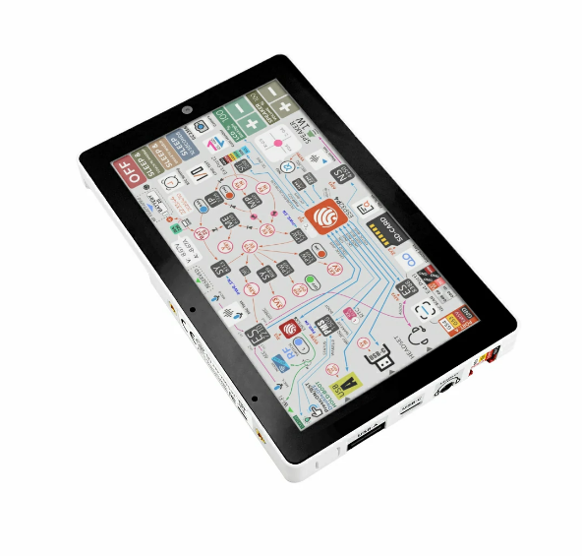
Figure 1 – The M5Stack Tab5 Development Board

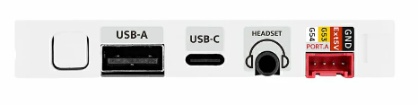
Figure 2 – Tab5 Bottom Side

- We can supply power to the Tab5 through its USB-C port. Connect the Tab5 USB-C port to your computer with a USB cable.
- The white “U” shaped button on the left is the On/Reset/Off button.
- Press the button once to turn on the screen. You should see the factory firmware running on the controller. It shows some useful data about the hardware and some live data on the LCD:

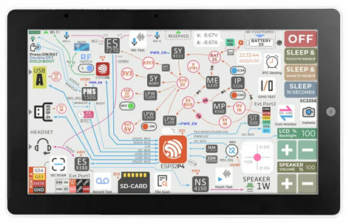
Figure 3 – Tab5 Running Factory Firmware

- Press and release the power button once. Note that the unit powers off and back on (we call this a reset).
- Double press and release the power button to turn the controller off.
- Look at the red PORT.A connector on the bottom of the controller. This connector supplies 5V Power (Red) and Ground (Black) to an external circuit and exposes two General Purpose Input/Output pins which connect directly to the microcontroller pins G53 (Yellow) and G54 (White). M5Stack uses these connectors to the sensors they supply. The sensors they sell even come with the cable to connect them to the Tab5!

The Dual LED Module
For any Hello World program, we need an LED to blink. Unfortunately, there’s not a blinkable LED built into our Dev board (a huge oversight on the part of M5Stack). CrazyUncleBurton didn’t let that stop him – he bought some M5Stack prototype modules and built his own!

The Circuit

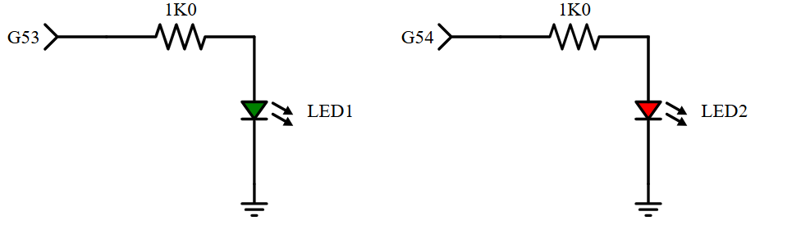
Figure 4 – Dual LED Module Schematic
There are two independent circuits inside the Dual LED Module. OK, they share the ground terminal of the port, but that’s it.
The green LED is connected to GPIO pin G53. A 1K resistor limits current to protect the LED and the microcontroller. When GPIO pin G53 is set to a logic high, the ESP32 outputs 3.3V to pin G53 and the green LED lights. When GPIO pin G53 is set to a logic low, the ESP32 outputs 0V to pin G53 and the green LED turns off.
The red LED is connected to GPIO G54. A 1K resistor limits current to protect the LED and the microcontroller. When GPIO Pin G54 is set to a logic high, the ESP32 outputs 3.3V to pin G54 and the red LED lights. When GPIO pin G54 is set to a logic low, the ESP32 outputs 0V to pin G53 and the green LED turns off.

PORT.A

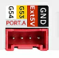
Figure 5 – PORT.A
Port A on M5Stack devices is a red-colored, 4-pin HY2.0-4P (Grove) connector utilizing GPIO 53 and 54. It enables quick, plug-and-play connectivity for sensors and actuators, often powered by the 5V rail. It can be configured for GPIO (digital I/O), or UART serial communication as well as I2C serial communication.

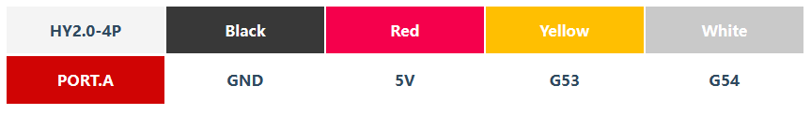

Figure 6 – PORT.A Pins and their Functions

There are four pins on the PORT.A connector:

Black – GND – This is the common reference terminal. It’s always 0V with respect to ground.

Red – 5V – This is a 5V reference / power supply from the port, intended to power any sensors or actuators. Why is it 5V when we’re working in a 3.3V ecosystem? My guess is to let us power and communicate with 5V sensors as well as 3.3V ones.

Yellow – G53 – This is connected to pin G53 on the microcontroller. It can be turned on and off programmatically. When it’s on, it will be +3.3V with respect to ground. When it’s off, it will be 0V.

White – G54 – This is connected to pin G54 on the microcontroller. It can be turned on and off programmatically. When it’s on, it will be +3.3V with respect to ground. When it’s off, it will be 0V.

PORT.A has some other special functions which we’ll cover in later lessons.

Connecting the Tab5 to the Dual LED Module

To connect the Dual LED module to the Tab5 dev board, use the 4 wire cable supplied with the module:

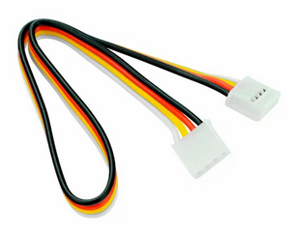
Figure 7 – Grove Cable

Note that there are polarity tabs molded into the cable plug and the corresponding sockets which only lets the cable connect the proper way:

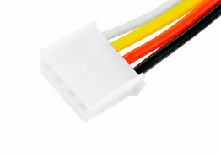
Figure 8 – Grove Polarization Tabs

Plug one end into the Dual LED module. Plug the other end into the Tab5 dev board.

